***Low-Level Design (LLD) Documentation***

**Foreign Direct Investment Data Analysis**



**Revision Number - 1.2**

**Last Date of Revision - 28/05/2024**

**RISHI KALPA MUKHERJEE**

**Document Control**

|  |  |  |  |
| --- | --- | --- | --- |
| **Date** | **Version** | **Description** | **Author** |
| 01/05/2024 | 1.0 | Introduction, Problem Statement | Rishi Kalpa Mukherjee |
| 14/05/2024 | 1.1 | Dataset Information,  Architecture Design | Rishi Kalpa Mukherjee |
| 28/05/2024 | 1.2 | Final Revision | Rishi Kalpa Mukherjee |

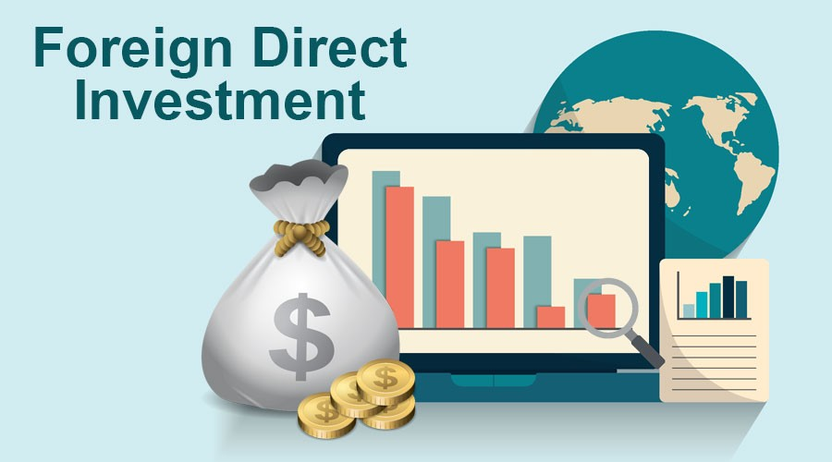

**Contents**

**Document Version Control......................................................**

1. **Introduction………………………………………………………………………………….4**
   1. What is Low-Level Design Document…………………………………………………….4
   2. Scope……………………………………………………………………………………………………..4
   3. Project Introduction………………………………………………………………………………4
2. **Problem Statement………………………………………………………………………6**
3. **Dataset Information…………………………………………………………………….6**
4. **Architecture…………………………………………………………………………………6**

4.1 Architecture Description…………………………………………………………………………6



1. **Introduction** 
   1. **What is Low-Level Design Document?**

The goal of the Low-level design document (LLDD) is to give the internal logic design of the actual program code for the Foreign Direct Investment Analysis dashboard. LLDD describes the class diagrams with the methods and relations between classes and programs specs. It describes the modules so that the programmer can directly code the program from the document.

* 1. **What is Scope?**

Low-level design (LLD) is a component-level design process that follows a step-by-step refinement process. The process can be used for designing data structures, required software architecture, source code ultimately, performance algorithms. Overall, the data organization may be defined during requirement analysis and then refined during data design work.

* 1. **Project Introduction**

The term foreign direct investment (FDI) refers to an ownership stake in a foreign company or project made by an investor, company, or government from another country. FDI is generally used to describe a business decision to acquire a substantial stake in a foreign business or to buy it outright to expand operations to a new region. The term is usually not used to describe a stock investment in a foreign company alone. FDI is a key element in international economic integration because it creates stable and long-lasting links between economies.

In today's globalized economy, foreign direct investment (FDI) and international funds have become increasingly important for businesses and investors alike. FDI refers to the investment made by a company or individual from one country into another country, while international funds are investment vehicles that invest in a diverse range of assets in multiple countries. These two concepts are closely linked, as international funds often invest in companies through FDI. Understanding the relationship between FDI and international funds is essential for investors looking to diversify their portfolio and companies seeking to expand their global presence.

* **How Does Foreign Direct Investment (FDI) Work?**

As noted above, foreign direct investment is a stake in a company or project by a foreign entity. Companies or governments considering an FDI generally consider target firms or projects in open economies that offer a skilled workforce and above-average growth prospects for the investor.

FDI inflows as a percentage of gross domestic product (GDP) are a good indicator of a nation’s appeal as a long-term investment destination.

* **Types of Foreign Direct Investment:**

Foreign direct investments are commonly categorized as horizontal, vertical, or conglomerate.

1. With a horizontal FDI, a company establishes the same type of business operation in a foreign country as it operates in its home country. A U.S.-based cell-phone provider buying a chain of phone stores in China is an example.
2. In a vertical FDI, a business acquires a complementary business in another country. For example, a U.S. manufacturer might acquire an interest in a foreign company that supplies it with the raw materials it needs.
3. In a conglomerate FDI, a company invests in a foreign business that is unrelated to its core business. Because the investing company has no prior experience in the foreign company’s area of expertise, this often takes the form of a joint venture.

Foreign investment plays a significant role in the development of an economy like India. Many countries provide many incentives for attracting foreign direct investment.

In the process of economic development, foreign capital helps to cover the domestic saving constraint and provide access to the superior technology that promotes efficiency and productivity of the existing production capacity and generate. New production opportunity.

India’s recorded GDP growth throughout the last decade has lifted millions out of poverty and made the country of favoured destination form for direct investment. A recent UN CTAD survey projected India is the second most important FDI destination after China.

1. **Problem Statement**

Investment is a game of understanding historic data of investment of investment objects under different events but it is still a game of chances to minimize the risk we apply analytics to find the equilibrium investment.

To understand the Foreign direct investment in India for the last 17 years from 2000-01 to 2016-17. This dataset contains sector and financial year-wise data of FDI in India Sector-wise investment analysis, Year-wise investment analysis.

1. **Dataset Information**

This Dataset includes Information regarding Sectors-wise and Year-wise FDI From FY 2000-01 to FY 2016-17.

1. **Architecture**

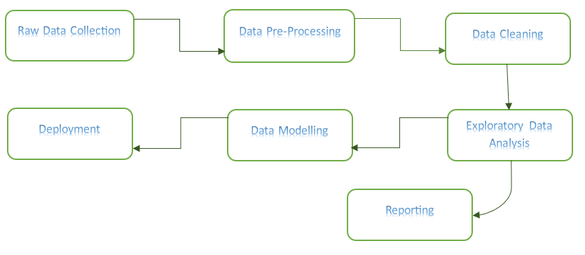

* 1. **Architecture Description**

**1. Raw Data Collection**

The Dataset was taken from iNeuron’s Provided Project Description Document. <https://drive.google.com/drive/folders/1M5z7z1NmWar7y1eFs67orfjqHL0iSViL?usp=sharing>

**2. Data Pre-Processing**

We performed data pre-processing and exploratory data analysis to feed the correct data for better analysis.

Process includes checking the top rows of data, descriptive summary of data, pair-plot, heatmap, handling missing data values, checking outlier by seeing boxplot and other important visualizations.

**3. Data Cleaning**

Data cleaning is the process of fixing or removing incorrect, corrupted, incorrectly formatted, duplicate, or incomplete data within a dataset.

a) Remove duplicate or irrelevant observations

b) Filter unwanted outliers

c) Renaming required attributes.

**4. Exploratory Data Analysis (EDA)**

Exploratory Data Analysis refers to the critical process of performing initial investigations on data to discover patterns, spot anomalies, test hypothesis and check assumptions with the help of summary statistics and graphical representations.

**5. Reporting**

Reporting is a most important and underrated skill of a data analytics field. Because being a Data Analyst you should be good in the easy and self-explanatory report because your model will be used by many stakeholders who are not from a technical background.

1. High-Level Design Document (HLD)

2. Low-Level Design Document (LLD)

3. Architecture

4. Wireframe

5. Detailed Project Report

6. PowerPoint Presentation

**6. Data Modelling**

Data Modelling is the process of analysing the data objects and their relationship to the other objects. It is used to analyse the data requirements that are required for the business processes. The data models are created for the data to be stored in a database. The Data Model's main focus is on what data is needed and how we have to organize data rather than what operations we have to perform.

**7. Deployment**

We created an intuitive dashboard in Tableau on FDI dataset.

Dashboard Demographics 1

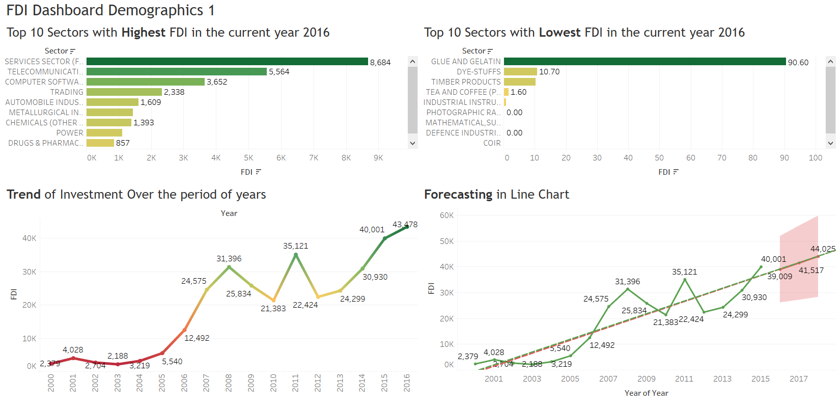

Dashboard Demographics 2

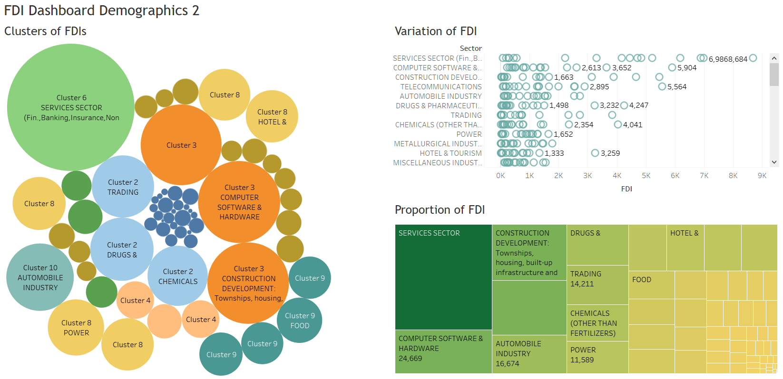

***End of Low-Level Design Documentation***

FDI Data Analysis